|  |  |  |
| --- | --- | --- |
| **Tech Saksham**  Final Project Report  **Track Name** |  |  |

**“YOUTUBE TRANSCRIPTER”**

**“College Name”**

|  |  |
| --- | --- |
| **ROLL NO** | **NAME** |
| 1981951035 | NIMMALAPUDI . DURGA SAHITHI |
|  |  |
|  |  |
|  |  |
|  |  |

|  |  |
| --- | --- |
|  | BY |
|  | N. DURGA SAHITTHI  MENTOR: UMAMAHESHWARI |
|  |  |

**ABSTRACT**  
Video transcript summarizer has got a lot of  
scope in today's world. It highlights the  
important topics from the video. People  
spend a noticeable amount of time binge  
watching YouTube videos, be it for  
entertainment, education purposes, or getting  
some important information or exploring their  
interests. If you wish to find a video to get  
any important information about a topic, it is  
a very difficult task to achieve as most of the  
videos are filled with insignificant buffer  
material. In most of the cases, the overall  
intent is to obtain some form of quality  
information from the video. This project  
brings forward a video summarization system  
based on Natural Language Processing and  
Machine Learning to generalize YouTube  
video transcripts for abstractive text  
summarization without losing the main  
elements and content. This project focuses  
on to reducing the length of the script for the  
videos

**INDEX**

|  |  |  |
| --- | --- | --- |
| **Sr. No.** | **Table of Contents** | **Page No.** |
| 1 | Chapter 1: Introduction | 1-7 |
| 2 | Chapter 2: Services and Tools Required | 7-8 |
| 3 | Chapter 3: Project Architecture | 8-15 |
| 4 | Conclusion | 15-16 |
| 5 | References | 17-18 |
| 6 | Code | 18-19 |

**CHAPTER 1**

**INTRODUCTION:**

YouTube is a video sharing platform, the second-  
most visited website, the second most used search  
engine, and is stronger than ever after more than 17  
years of being online. YouTube uploads about  
720,000 hours of fresh video content per day. The  
number of videos available on the web platform is  
steadily growing. It has become increasing easy to  
watch videos on YouTube for anything, from  
cooking videos to dance videos to motivational  
videos and other bizarre stuff as well. The content is  
available worldwide primarily for educational  
purposes. The biggest challenge while extracting  
information from a video is that the viewer has to  
watch the entire video to understand the context,  
unlike images, where data can be gathered from a

single frame. If a viewer has low network speed or  
any other device limitation can lead to watch video  
with a low resolution that makes it blurry and hectic  
to watch. Also, in between advertisements are too  
frustrating. So, removing the junk at the start and  
end of the concerned video as well as skipping  
advertisements, and getting is summary to directly  
jump to your part of interest is valuable and time  
efficient.

This project focuses on to reducing the length of the  
script for the videos. Summarizing transcripts of  
such videos automatically allows one to quickly  
lookout for the important patterns in the video and  
helps to save time and effort to go through the whole  
content of the video. The most important part of this  
project will be its ability to string together all the  
necessary information and concentrate it into a small  
paragraph. Video summarization is the process of  
identifying the significant segments of the video and  
produce output video whose content represents the  
entire input video. It has advantages like reducing  
the storage space used for the video. This project  
will give an opportunity to have hands-on  
experience with state-of-the-art NLP technique for  
abstractive text summarization and implement an  
interesting idea suitable for intermediates and are

refreshing hobby project for professionals.

* 1. **Feature:**

A lot of technical and educational applications  
involving generation of large amounts of video and  
multimedia are top contender of using video  
summarization technique. These include film  
industry, advertisement creation, data visualization,  
match highlights of sports match thus removing redundancy, reducing computational time and  
storage requirements

* 1. **Advantages:**
* Research/Patents:- This application can be used to  
  extract important vital claims acrosspatents or  
  research papers thus saving time and effort.
* Crash Course :- Students who wants to watch  
  YouTube videos for their study can easily get a  
  quick idea of the topic and concisely will get a quick  
  read of the video and can easily check whether the  
  video is relevant for them or not.
* Quick Notes:- Students who don't want to attend  
  the boring lectures or somehow, they have missed the classes, they can use this application to build the notes from the summary of the video. Most students browse on YouTube a day before their exams and watch the video on double speed, but in reducing the watch time by half, it doubles the confusion about a totally new topic. Thus, making things way worse than they originally were. So, removing the junk at  
  the start and end of the concerned video as well as skipping advertisements, and getting is summary to directly jump to your part of interest is valuable and time efficient
* Customer feedback:- Most of the time getting  
  long feedback from the customers for any particular product, this application helps to summarize their long feedback and can easily predict whether the feedback is positive or negative.
* Hearing Impaired Person:- This application is  
  beneficial for hearing impaired persons as they can
  1. **Scope**

Students who don't want to attend  
the boring lectures or somehow, they have missed the classes, they can use this application to build the notes from the summary of the video. Most students browse on YouTube a day before their exams and watch the video on double speed, but in reducing the watch time by half, it doubles the confusion about a totally new topic. Thus, making things way worse than they originally were. So, removing the junk at the start and end of the concerned video as well as  
skipping advertisements, and getting is summary to directly jump to your part of interest is valuable and time efficient

* 1. **Future Work:**

Implementing an android application it will be helpful for future students and stored at database easy to search and retrieve the data easily.

* 1. **LITERATURE SURVEY:**  
     NLP or Natural Language Processing is one of the  
     fastest-growing tech fields right now. From message  
     spam filter to medical diagnosis with a chatbot, NLP  
     is everywhere. Some of the hot use cases of NLP  
     right now are text summarization, chatbot, machine  
     translation, text generation, etc. Have you ever  
     imagined getting a short summary of a big YouTube  
     tutorial or video for quick reading before watching  
     the video, definitely this will help you to save a lot  
     of your time by getting a quick understanding or  
     summarization about the video in a short time? This  
     project is about discussing a mini NLP project, a  
     YouTube Transcript Summarizer which will  
     summarize the content of the YouTube video. For  
     many videos, the main content of the videos is only  
     50-60% of the total length, so the YouTube  
     summarizer will summarize the content of the video  
     by keeping all the important points and making it  
     short and easily understandable. This will be useful  
     in getting the summary of several lecture videos  
     easily.

**CHAPTER 2**

**SERVICES AND TOOLS REQUIRED**

**libraries:**

libraries like Flask, YouTube transcriptive api, Hugging-face libraries of Transformers, Speech recognition api, google translate api, Pytube, ffmpeg and many more which can be used in many realworld applications.

Tools and Software used generally we used visual code to run python libraries and html for front end with the help of cascading stylesheet will be helpful to reach everyone easily without any ones help.

**CHAPTER 3**

**PROJECT ARCHITECTURE**

**3.1 Architecture:**

**USER FRONTEND BACKEND**

|  |  |  |
| --- | --- | --- |
|  | **HTML 5** | **python**  **Database** |

This project basically aims at providing clean and  
concise summary of the YouTube videos that the  
user don't want to waste their time at. This project  
uses popular python libraries like Flask, YouTube  
transcript api, Hugging-face libraries of  
Transformers, Speechrecognitionapi, google  
translate api, Pytube , ffmpeg and many more which  
can be used in many real world applications.

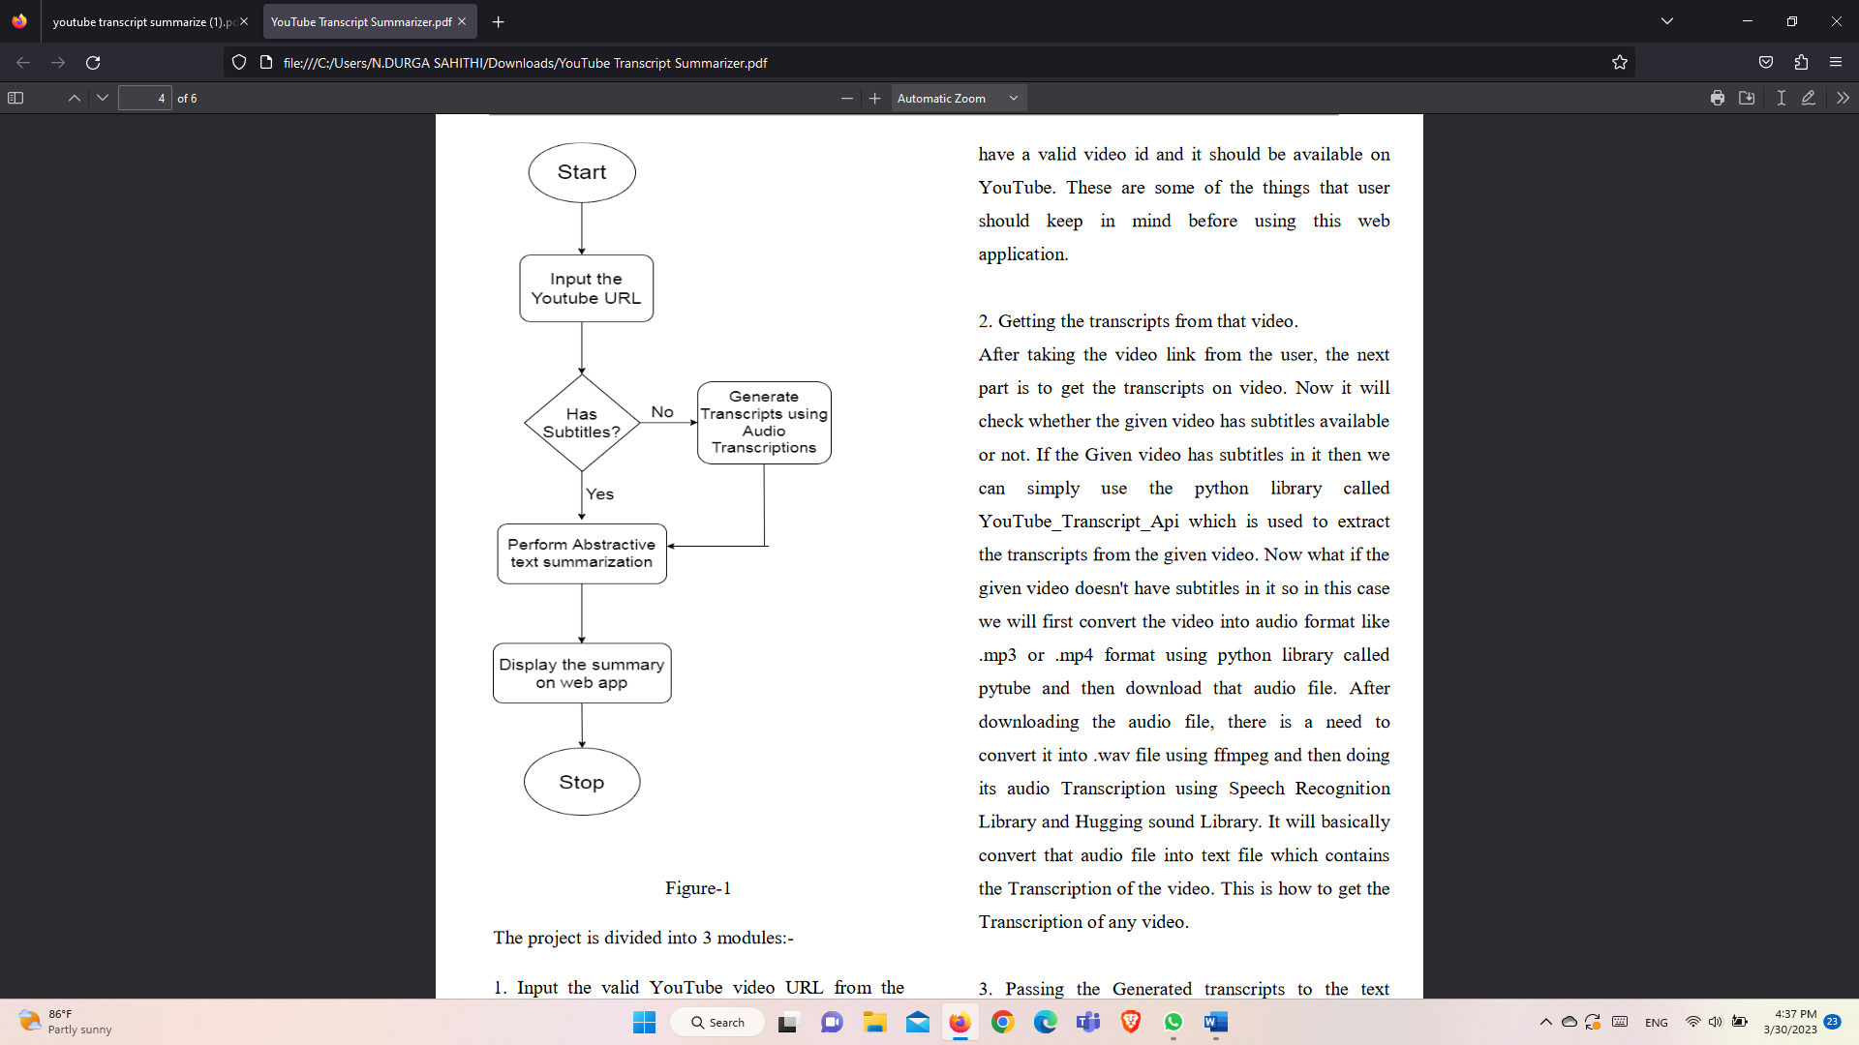

The project is divided into 3 modules:-  
1. Input the valid YouTube video URL from the  
user.  
The First step is to getting the video link from the  
user which user wants to  
summarize. The video should be Recorded, it should

have a valid video id and it should be available on  
YouTube. These are some of the things that user  
should keep in mind before using this web  
application.  
2. Getting the transcripts from that video.  
After taking the video link from the user, the next  
part is to get the transcripts on video. Now it will  
check whether the given video has subtitles available  
or not. If the Given video has subtitles in it then we  
can simply use the python library called  
YouTubeTranscriptApi which is used to extract  
the transcripts from the given video. Now what if the  
given video doesn't have subtitles in it so in this case  
we will first convert the video into audio format like  
.mp3 or .mp4 format using python library called  
pytube and then download that audio file. After  
downloading the audio file, there is a need to  
convert it into .wav file using ffmpeg and then doing  
its audio Transcription using Speech Recognition  
Library and Hugging sound Library. It will basically  
convert that audio file into text file which contains  
the Transcription of the video. This is how to get the  
Transcription of any video.  
3. Passing the Generated transcripts to the text  
summarizer.  
Now this is the main phase of the project where the  
whole project depends upon. This phase basically

includes the text summarization. Now there are  
mainly two types of summarization techniques:-  
**Extractive Summarization:-** This is a text  
summarization technique which basically extracts  
the important patterns like phrases and sentences  
from the video, group together and form a concise  
summary of the YouTube video. It will not produce  
any new sentence. Some of them are:- TextRank,  
LexRank, LSA, Luhn etc.  
**Abstractive Summarization**:- This is another text  
summarization technique which is a new start of art  
method because it generates the sentences in a newly  
formed way. It will basically reproduce the sentence  
which is more clean and concise than the original  
sentence and in a most human readable form. This is  
better than extractive summarization techniques.  
This can be easily implemented by using Bert  
Transformers or pipeline api.  
In this phase, implementation will be there of the  
abstractive summarization using pipeline api. User  
can also change the language of the generated

summary according to his/her requirements. For this  
purpose, google transapi is used to do the language  
translation of text. It supports 108 languages to  
translate. Finally converting the whole project into a web  
application using Flask Framework and one can

easily deploy it on cloud platforms like Heroku,  
AWS, etc.

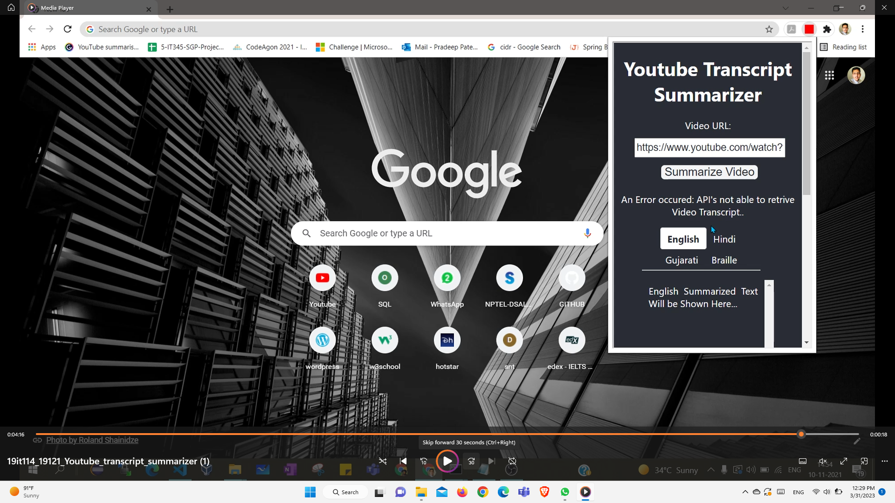

**If u give invalid URL u will get error occurred message.**

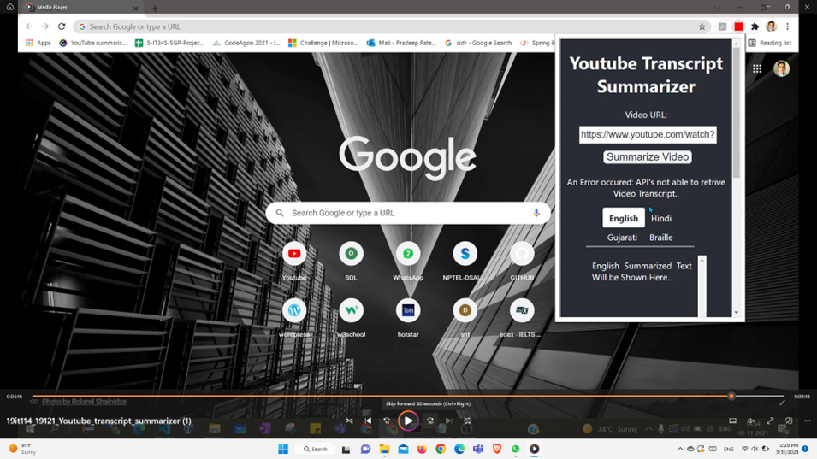

**If u give any URL of youtube u will get the summary of that particular information of that youtube.**

**CONCLUSION**

Recently, video summarization has attracted  
considerable interest from researchers and as a  
result, various algorithms and techniques have

Been proposed. This project is to provide a web app or a chrome extension that can be used to summarize the YouTube video content and extract important information from those patterns by using state-of- the-art Natural Language Processing methods for abstractive text summarization and Machine Learning for classification.

**REFERENCES**

* Hank Liao, Erik McDermott, Andrew Senior“Large  
  scale deep neural network acoustic modeling with  
  semi-supervised training data for YouTube video  
  transcription” December 2013.
* Gaurav Sharma, Shaba Parveen Khan, Shivanshu  
  Sharma, Syed Ubed Ali “Summarizer For Easy  
  Video Assessment”  
  Volume: 3 Issue:04-April-2021
* Atluri Naga, Laggisetti Valli, JahnaviDuvru “Video  
  Transcript Summarizer”  
  Issue: 11 March 2022
* Krishna Kulkarni, RushikeshPadaki “Video Based  
  Transcript Summarizer for Online Courses using  
  Natural Language Processing”  
  Issue: 18 December 2021
* EvalampoisApostolidis, Eleni Adamantidou,  
  Vasileios Mezaris “Video Summarization Using  
  Deep Neural Networks: A Survey”  
  Pages 1838-1863 Issue: 13 November 2021
* G. PRIYANKA, M. PRASHA MEENA “Survey and  
  Evaluation on Video Summarization Techniques”  
  Issue: 28 May 2020
* A. Workie, R. Sharma, Y. N. Chung “Digital Video  
  Summarization Techniques” Volume 09 Issue: 01  
  January 2020
* A. Dilawari, M. Usman Khan, “ASoVS: Abstractive  
  Summarization of Video Sequences” Pages 29253-  
  29263 Issue: 11 March 2019
* Cüneyt M. Taskiran, Arnon Amir, Dulce B.  
  Ponceleon, Edward J. Delp. “AutomatedVideo  
  Summarization Using Speech Transcripts”.
* AniquaDilawari, Muhammad usmanghani khan.  
  “Abstractive Summarization of  
  Video Sequences” IEEE Access, 2019.

**CODE**

**Code through Git Hub Repo Link:**

**https://github.com/sahithi6094/youtube_transcript_api_master**